# Demand, Supply & Price determination

**Demand** in economics is how many goods and services are bought at various prices during a certain period of time. Demand is the consumer's need or desire to own the product or experience the service subject to the willingness and ability of the consumer to pay for the good or service at the price offered.

Demand is the underlying force that drives everything in the economy. Fortunately for economics, people are never satisfied. They always want more. This drives [economic growth](http://useconomy.about.com/od/grossdomesticproduct/f/Economic-Growth.htm) and expansion. Without demand, no business would ever bother producing anything.

**Law of demand:** There is an inverse relationship between quantity demanded and its price. The law refers to the direction in which quantity demanded changes due to change in price. The economists call it as **law of demand**. In simple words the law of demand states that other things being equal more will be demanded at lower price and lower will be demanded  at higher price.

**Definition**

1. Alfred Marshal says that the amount demanded increase with a fall in price, diminishes with a rise in price.
2. C.E. Ferguson says that according to law of demand, the quantity demanded varies inversely with price.
3. Paul A. Samuelson says that law of demand states that people will buy more at a lower prices and buy less at higher prices, other things remaining the same.

**Assumptions of the law**

1. There is no change in income of consumers.
2. There is no change in quality of product.
3. There is no substitute of the commodity.
4. The prices of related commodities remain the same.
5. There is no change in customs.
6. There is no change in taste and preference of consumers.
7. The size of population remains the same.
8. The climate and weather conditions are same.
9. The tax rates and other fiscal measures remain the same.

**Explanation of the law**

The relationship between price of a commodity and its demand depends upon many factors. The most important factor is nature of commodity. The demand schedule shows response of quantity demanded to change in price of that commodity. This is the table that shows prices per unit of commodity ands amount demanded per period of time. The demand of one person is called individual demand. The demand of many persons is known as market demand. The market demand schedule means 'quantities of given commodity which all consumers want to buy at all possible prices at a given moment of time'. The demand schedules of all individuals can be added up to find out market demand schedule.

**Demand schedule**

|  |  |
| --- | --- |
| Price in Rs. | Demand in Kg. |
| 5 | 100 |
| 4 | 200 |
| 3 | 300 |
| 2 | 400 |

The table shows the demand of all the consumers in a market. When the price decreases there is increase in demand for goods and vice versa. When price is Rs. 5 demand is 100 kilograms. When the price is Rs. 4 demand is 200 kilograms. Thus the table shows the total amount demanded by all consumers various price levels.

**Diagram**

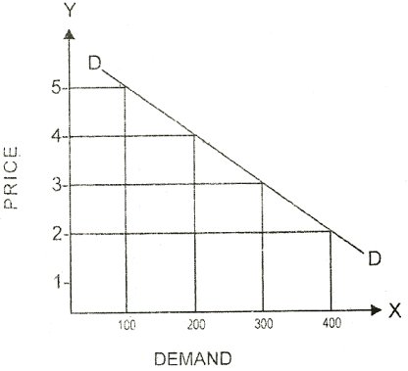

There is same price in the market. All consumers purchase commodity according to their needs. The market demand curve is the total amount demanded by all consumers at different prices. The market demand curve slopes from left down to the right.

**Why demand curve falls**

1. **Marginal utility decreases:** When a consumer buys more units of a commodity, the marginal utility of such commodity continue to decline. The consumer can buy more units of commodity when its price falls and vice versa. The demand curve falls because demand is more at lower price.
2. **Price effect:** When there is increase in price of commodity, the consumers reduce the consumption of such commodity. The result is that there is decrease in demand for that commodity. The consumers consume more or less of a commodity due to price effect. The demand curve slopes downward.
3. **Income effect:** Real income of consumer rises due to fall in prices. The consumer can buy more quantity of same commodity. When there is increase in price, real income of consumer falls. This is income effect that the consumer can spend increased income on other commodities. The demand curve slopes downward due to positive income effect.
4. **Same price of substitutes:** When the price of a commodity falls, the prices of substitutes remaining the same, consumer can buy more of the commodity and vice versa. The demand curve slopes downward due to substitution effect.
5. **Demand of poor people:** The income of people is not the same, The rich people have money to buy same commodity at high prices. Large majority of people are poor, They buy more when price fall and vice versa. The demand curve slopes due to poor people.
6. **Different uses of goods:** There are different uses of many goods. When prices of such goods increase these goods are put into uses that are more important and their demand falls. The demand curve slopes downward due to such goods.

**Movement along the demand curve vs. Shift in the demand curve**

When quantity demanded of a commodity changes due to a change in its price, keeping other factors constant, it is known as change in quantity demanded. It is graphically expressed as a movement along the same demand curve.

If there is a change in price, there is a movement along the demand curve. An increase in price, P1 to P2 causes a change in quantity demand from Q1 to Q2 along the demand curve D.

A change in price doesn’t shift the demand curve – we merely move from one point of demand curve to another.

**Diagram of movement Along Demand Curve**

Q1

Q2

P1

P2

D

#### Shift in the Demand Curve

A shift in the demand curve occurs when the whole demand curve moves to the right or left. For example, an increase in income would mean people can afford to buy more of a particular product even at the same price. The following diagram shows increased demand Q2 at the same price P1. The new demand curve D2 shifts outwards towards the right from the earlier demand curve D1.

#### Diagram Showing Shift in Demand Curve

#### 

D1 D2



Q1 Q2

#### The Demand curve could shift to the right if:

1. The good became more popular (e.g. fashion changes or successful advertising campaign)
2. The price of a substitute good increases
3. The price of a complement good decreases
4. A rise in incomes (assuming good is a normal good, positive income elasticity)
5. Seasonal factors

**Exceptions to the law of demand**

In the below mentioned cases, price and demand move in the same direction i.e. a rise in price brings about an increase in demand.

1. **Inferior goods:** The law of demand does not apply in case of inferior goods. When price of inferior commodity decreases and its demand also decrease and amount so saved in spent on superior commodity. Inferior goods are also called Giffen goods.
2. **Veblen good**: A good for which people's preference for buying them increases as a direct function of their price, as greater price confers greater status.
3. **Demonstration effect** The law of demand does not apply in case of diamond and jewelry. There is more demand when prices are high. There is less demand due to low prices. The rich people like to demonstrate such items that only they have such commodities.
4. **Ignorance of consumers**The consumer usually judge the quality of a commodity from its price. A low priced commodity is considered as inferior and less quantity is purchased. A high priced commodity is treated as superior and more quantity is purchased. The law of demand does not apply in this case.
5. **Less supply:** The law of demand does not work when there is less supply of commodity. The people buy more for stock purpose even at high price. They think that commodity will become short.
6. **Depression:** The law of demand does not work during period of depression. The prices of commodities are low but there is increase in demand. it is due to low purchasing power of people.
7. **Speculation:** The law does not apply in case of speculation. The speculators start buying share just to raise the price. Then they start selling large quantity of shares to avoid losses.
8. **Out of fashion:** The law of demand is not applicable in case of goods out of fashion. The decrease in prices cannot raise the demand of such goods. The quantity purchased is less even though there is falls in prices.

**Importance of the law**

1. **Price determination:** A monopolist can determine price of a commodity on the basis of such law. He can know the effect on demand due to increase or decrease in price. The demand schedule can help him to determine the most suitable price level.
2. **Tax on commodities:** The law of demand is important for tax authorities. The effect of tax on different commodities is checked. The commodity must be taxed if its demand is relatively inelastic. A commodity cannot be taxed if its sales fall to great extent.
3. **Agricultural prices:** The law of demand is useful to determine agricultural prices. When there are good crops, the prices come down due to change in demand. In case of bad crops, the prices go up if demand remains the same. The poverty of farmers can be determined.
4. **Planning:** Individual demand schedule is used in planning for individual goods and industries. There is need to know the effect of change in price on the demand of commodity at national and world level. The nature of demand schedule helps to know such effect.

**Price elasticity of demand**

**Price elasticity of demand** measures the responsiveness of demand after a change in a product's own price. The formula for calculating the co-efficient of elasticity of demand is given below. The word "coefficient" is used to describe the values for price elasticity of demand

***Percentage change in quantity demanded / Percentage change in price***

**Values for Price Elasticity of Demand (EP)**

1. **If EP = 0** demand is **perfectly inelastic.** Demand does not change at all when the price changes. The demand curve will be vertical. This happens with goods which have no substitutes e.g. life saving drugs.
2. **If EP is between 0 and 1** (i.e. the % change in demand from A to B is smaller than the percentage change in price), then **demand is inelastic**.

Goods which are inelastic tend to have some or all of the following features:

1. They have few or no close substitutes, e.g. petrol, cigarettes.
2. They are necessities, e.g. if you have a car, you need to keep buying petrol, even if price of petrol increases
3. They are addictive, e.g. cigarettes.
4. They cost a small % of income or are bought infrequently.
5. **If EP = 1** (i.e. the % change in demand is exactly the same as the % change in price), then demand is **unit elastic**. A 15% rise in price would lead to a 15% contraction in demand leaving total spending the same at each price level.
6. **If EP > 1**, then demand responds more than proportionately to a change in price i.e. **demand is elastic**. For example if a 10% increase in the price of a good leads to a 30% drop in demand. The price elasticity of demand for this price change is 3.

Goods which are elastic, tend to have some or all of the following characteristics:

1. They are luxury goods, e.g. sports cars
2. They are expensive and a big percentage of income is spent for them e.g. holiday tours
3. Goods with many substitutes and a very competitive market.
4. Bought frequently
5. **If EP** is **infinite,** it means that there is an infinite change in demand with the slightest change in price. The demand curve is horizontal meaning the if the seller raises his price he will lose all his customers. This happens when the commodity has large number of substitutes

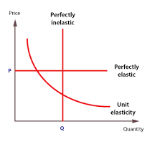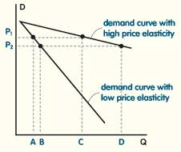

*\*\* Note: Perfectly elastic and perfectly inelastic are two extreme situations. One would hardly find them in reality. In the short term demand is usually more inelastic because it takes time to find alternatives. Example of Inelastic demand: Necessities like salt, food grains, vegetables, milk. Elastic demand: Comforts and luxuries like LED TV, mobile phones, Air-conditioners etc.*

**Income elasticity of demand (EY)**

The income [elasticity](https://www.boundless.com/economics/definition/elasticity/) of [demand](https://www.boundless.com/economics/definition/demand/) is the ratio of the percentage change in demand to the percentage change in income.

1. **High income elasticity of demand (EY >1):** An increase in income is accompanied by a proportionally larger increase in quantity demanded. This is typical of a [luxury](https://www.boundless.com/economics/definition/luxury/) or [superior good](https://www.boundless.com/economics/definition/superior-good/).
2. **Unitary income elasticity of demand (EY =1):** An increase in income is accompanied by a proportional increase in quantity demanded.
3. **Low income elasticity of demand (EY <1):** An increase in income is accompanied by less than a proportional increase in quantity demanded. This is characteristic of a [necessary good](https://www.boundless.com/economics/definition/necessary-good/).
4. **Zero income elasticity of demand (EY =0):** A change in income has no effect on the quantity bought. These are called sticky goods.
5. **Negative income elasticity of demand (EY <0):** An increase in income is accompanied by a decrease in the quantity demanded. This is an inferior good (all other goods are normal goods). The consumer may be selecting more luxurious [substitutes](https://www.boundless.com/economics/definition/substitute/) as a result of the increase in income.

**Cross elasticity of demand (EXY)**

Cross elasticity of demand (EXY) measures the percentage change in quantity demand for a good after the change in price of another.

**Substitute goods**

For goods which are substitutes, we expect to see a positive cross elasticity of demand. If the price of Britannia bread increases, people will buy more of an alternative, such as Modern bread.

Weak substitutes like tea and coffee will have a low cross elasticity of demand

Alternative brands of chocolate, e.g. Dairy Milk vs Nesle are quite similar, so will have a higher cross elasticity of demand.

**Complement goods**

These are goods which are used together, therefore the cross elasticity of demand is negative. If the price of one goes up, you will buy less of both goods.

For example, if the price of printer goes up, people will also buy less of printer cartridges.

On the other hand, if the price of DVD players goes down, people will buy more DVD players and also there will be a increase in demand for DVD disks.

**Supply**

Supply can be defined as "the total quantity of a good or service that is available for sale at a given price at a given period of time.”

**Law of Supply**

The law of supply is a fundamental principle of economic theory. It states that an increase in price will result in an increase in the quantity supplied, all else held constant.

An upward sloping supply curve, which is also the standard depiction of the supply curve, is the graphical representation of the law of supply. As the price of a good or service increases, the quantity that suppliers are willing to produce increases and this relationship is captured as a movement along the supply curve to a higher price and quantity combination.

**Diagram**

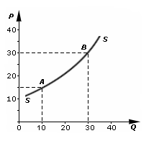

**Movement along Supply curve vs. Shift in the Supply curve**

* A change in the [price](https://www.boundless.com/economics/definition/price/) of a good or service, holding all else constant, will result in a movement along the [supply curve](https://www.boundless.com/economics/definition/supply-curve/).
* A change in the [cost](https://www.boundless.com/economics/definition/cost/) of an [input](https://www.boundless.com/economics/definition/input/) will impact the cost of producing a good and will result in a shift in supply; supply will shift outward if costs decrease and will shift inward if they increase.
* A change in the expected [demand](https://www.boundless.com/economics/definition/demand/) for a good or service will result in a shift in supply; supply will shift outward if enthusiasm is expected to increase and will shift inward if there is an expectation for consumers preferences to change in favor of an alternate good or service.  
    
    
  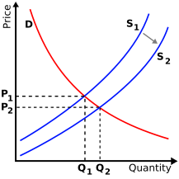

**Price determination**

Equilibrium is a state in market where economic forces are balanced and in the absence of external influences the (equilibrium) values of economic variables will not change.

It is the point at which quantity demanded and quantity supplied is equal. Market equilibrium, for example, refers to a condition where a market price is established through competition such that the amount of goods or services sought by buyers is equal to the amount of goods or services produced by sellers. This price is often called the equilibrium price.

In the graph below the point at which the demand curve meets the supply curve is the equilibrium price.

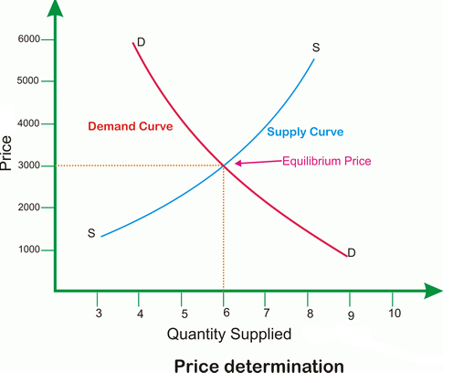

Equilibrium is ‘self righting’. It means that if we try to move away from the equilibrium situation it will revert back to its original position, if there is no external disturbance. Figure below explains the concept.

In this diagram the equilibrium price is P* and the quantity supplied Q*. However, the prices have been increased to P2. As the price has increased it will lead to more suppliers entering the market and supply increasing to Qs. At the same time, a increase in price to P2 will lead to a fall in demand (as per the law of demand) i.e. Qd. This will create an excess supply situation. Now the suppliers will find it difficult to sell their goods and they will have to reduce their price to attract more consumers. This will go on till the price again reaches its initial level i.e. P*. Hence the situation is self righting if the prices are raised without any external reason.

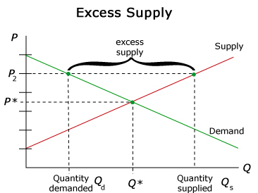

In the diagram below we can see that the prices have been artificially reduced from P* to P1. This leads to a fall in supply from Q* to Qs (as per law of supply). As the prices fall from P* to P1, people can afford to buy more of that good and demand increase from Q* to Qd. Again an **excess demand** situation is created. In order to get the most out of this situation the suppliers will start increasing their price. On the other hand demand will start falling as the prices increase. This will all continue till the prices settle at equilibrium price i.e. P*.

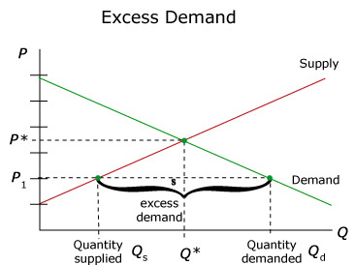

**Movement to a new equilibrium**

The equilibrium price remains unchanged till the demand and supply curves retain their position. The moment there is a shift in any of the components, a new equilibrium will be formed.

**Effect of change in Demand and Supply**

|  |  |  |  |
| --- | --- | --- | --- |
| **Demand** | **Supply** | **Equilibrium price** | **Equilibrium quantity** |
| Increase | Unchanged | Rise | Rise |
| Decrease | Unchanged | Fall | Fall |
| Unchanged | Increase | Fall | Rise |
| Unchanged | Decrease | Rise | Fall |